**Project Title:**

Airline Reservation System

**Name for the Website:**

Airprice

**Project Description:**

In this project, we implement an airline reservation website which is similar to Priceline.com. We assume that all of the fights are daily flights. A new user can create an account first, then search and add flights to his/her cart. There are two flight options provided for searching: one-way and round-trip, users can also filter the results according to whether or not there is an intermediate stop. An admin user can add, delete and update any flights. We make an assumption that all of the operations are cascading.

**Database Design:**

CREATE TABLE `airplane` (

`ID` varchar(10) NOT NULL,

`type` varchar(10) NOT NULL,

`company` varchar(20) NOT NULL,

PRIMARY KEY (`ID`)

)

CREATE TABLE `airport` (

`code` varchar(10) NOT NULL,

`name` varchar(50) NOT NULL,

`city` varchar(20) NOT NULL,

`state` varchar(20) NOT NULL,

`country` varchar(20) NOT NULL,

PRIMARY KEY (`code`)

)

CREATE TABLE `book` (

`ID` int(11) NOT NULL AUTO_INCREMENT,

`time` datetime NOT NULL,

`date` date NOT NULL,

`flightno` varchar(10) NOT NULL,

`username` varchar(45) NOT NULL,

`classtype` varchar(20) NOT NULL,

`paid` int(1) DEFAULT '0',

PRIMARY KEY (`ID`,`flightno`),

KEY `username_idx` (`username`),

KEY `classname_idx` (`classtype`),

KEY `flightno_idx` (`flightno`,`classtype`),

CONSTRAINT `flightno` FOREIGN KEY (`flightno`, `classtype`) REFERENCES `class` (`number`, `name`) ON DELETE CASCADE ON UPDATE CASCADE,

CONSTRAINT `username` FOREIGN KEY (`username`) REFERENCES `passanger` (`username`) ON DELETE NO ACTION ON UPDATE NO ACTION

)

CREATE TABLE `class` (

`number` varchar(10) NOT NULL,

`name` varchar(20) NOT NULL,

`capacity` int(11) NOT NULL,

`price` float NOT NULL,

PRIMARY KEY (`number`,`name`),

KEY `number_idx` (`number`),

CONSTRAINT `number` FOREIGN KEY (`number`) REFERENCES `flight` (`number`) ON DELETE CASCADE ON UPDATE CASCADE

)

CREATE TABLE `flight` (

`number` varchar(20) NOT NULL,

`airplane_id` varchar(10) NOT NULL,

`departure` varchar(10) NOT NULL,

`d_time` time NOT NULL,

`arrival` varchar(10) NOT NULL,

`a_time` time NOT NULL,

PRIMARY KEY (`number`),

KEY `code_idx` (`departure`,`arrival`),

KEY `airplaneid_idx` (`airplane_id`),

KEY `arrival_idx` (`arrival`),

CONSTRAINT `airplaneid` FOREIGN KEY (`airplane_id`) REFERENCES `airplane` (`ID`) ON DELETE CASCADE ON UPDATE CASCADE,

CONSTRAINT `arrival` FOREIGN KEY (`arrival`) REFERENCES `airport` (`code`) ON DELETE CASCADE ON UPDATE CASCADE,

CONSTRAINT `departure` FOREIGN KEY (`departure`) REFERENCES `airport` (`code`) ON DELETE CASCADE ON UPDATE CASCADE

)

CREATE TABLE `passanger` (

`username` varchar(30) NOT NULL,

`firstname` varchar(45) DEFAULT NULL,

`middlename` varchar(45) DEFAULT NULL,

`lastname` varchar(45) DEFAULT NULL,

`email` varchar(45) DEFAULT NULL,

`cellphone` varchar(15) DEFAULT NULL,

`gender` varchar(10) DEFAULT NULL,

`birthday` date DEFAULT NULL,

`password` varchar(45) NOT NULL,

PRIMARY KEY (`username`)

)

**Languages Used for Implementation:**

PHP 5 for server side scripting.

Javascript/JQuery/Ajax for client side scripting.

Bootstrap/CSS for design the web pages.

**Work Division:**

Qun Niu:

User signup and User login and logout, form validation, database schema design

Song Tao:

List available tickets in the system, search for a specific item, add items to the cart and checkout, form validation, database schema design

Xianchu Chen:

Show history of items for user, operations for Admin users, form validation, database schema design

**Screenshots:**

1. Homepage

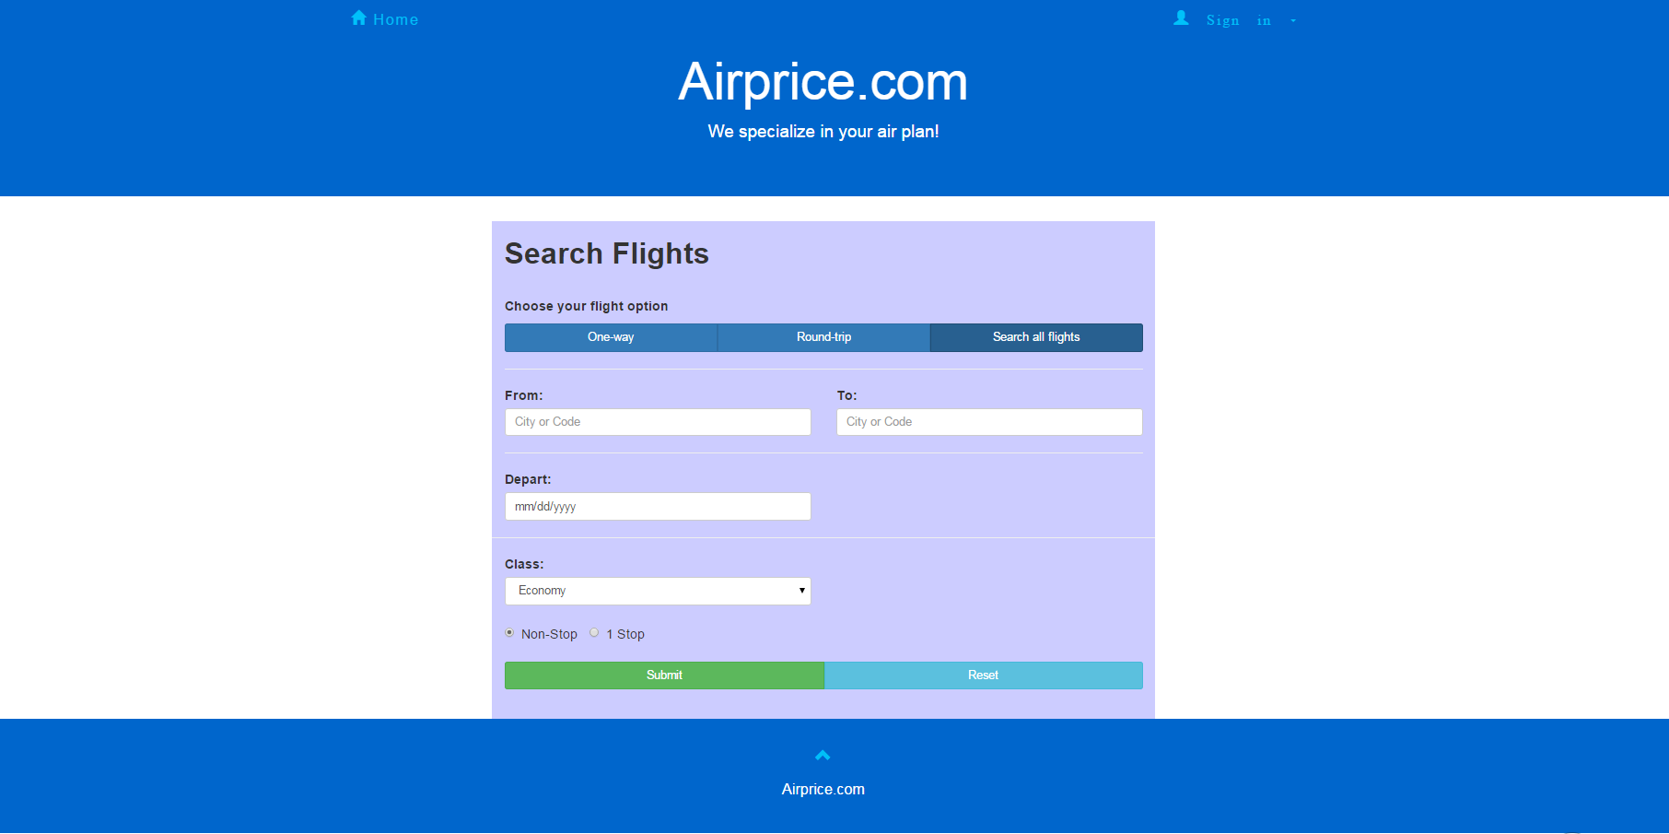

2. Sign up

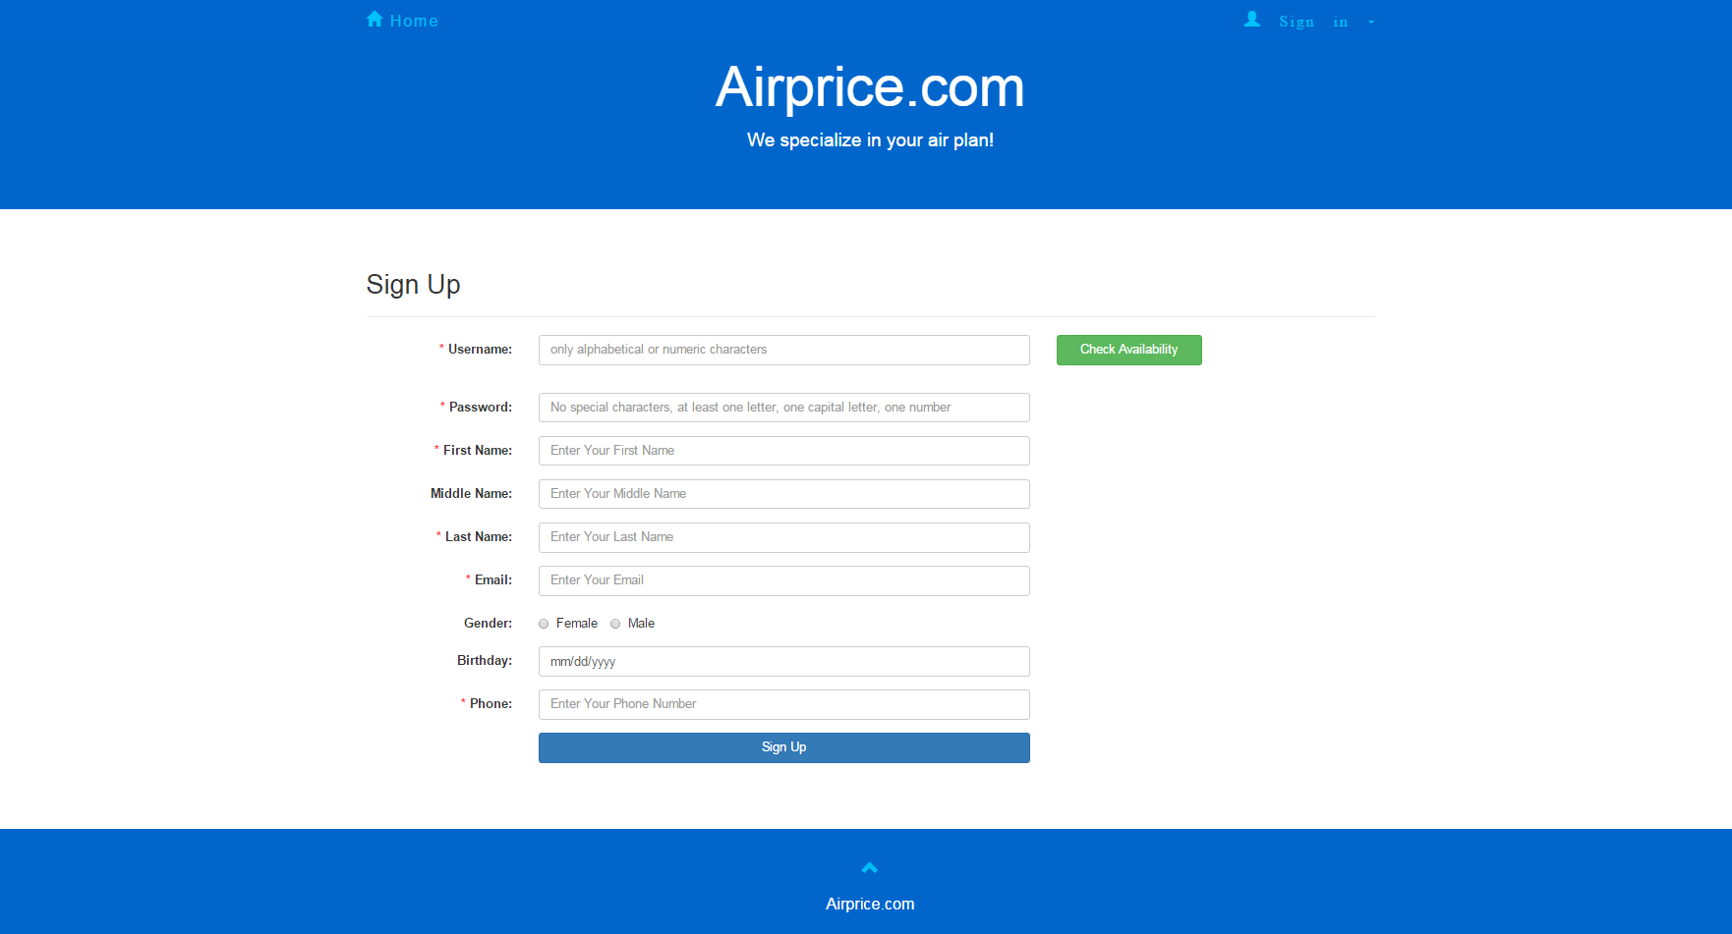

3. Sign in

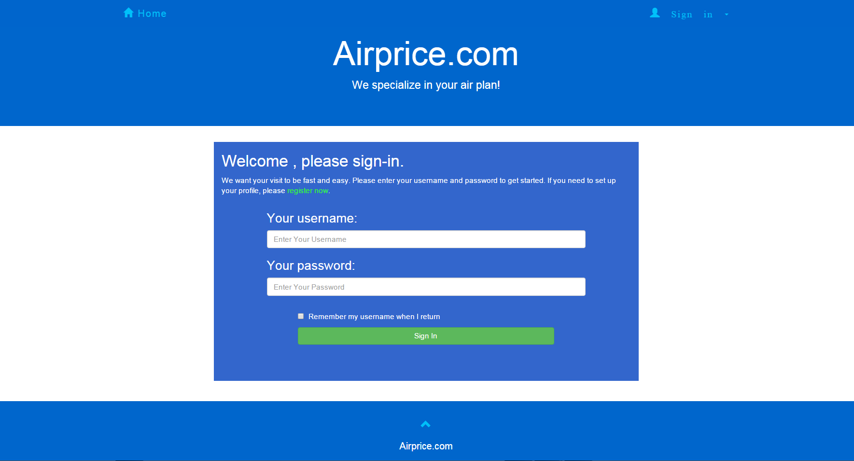

4. Shopping cart

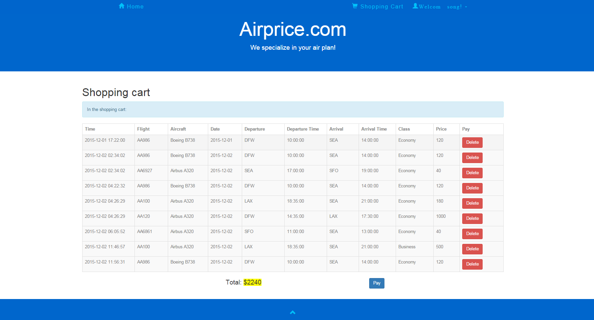

5. History

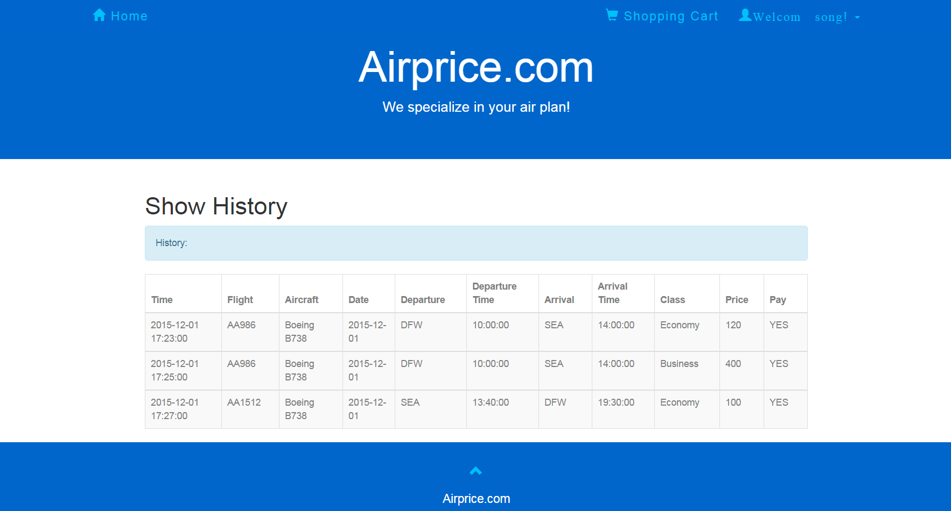

6. Search result

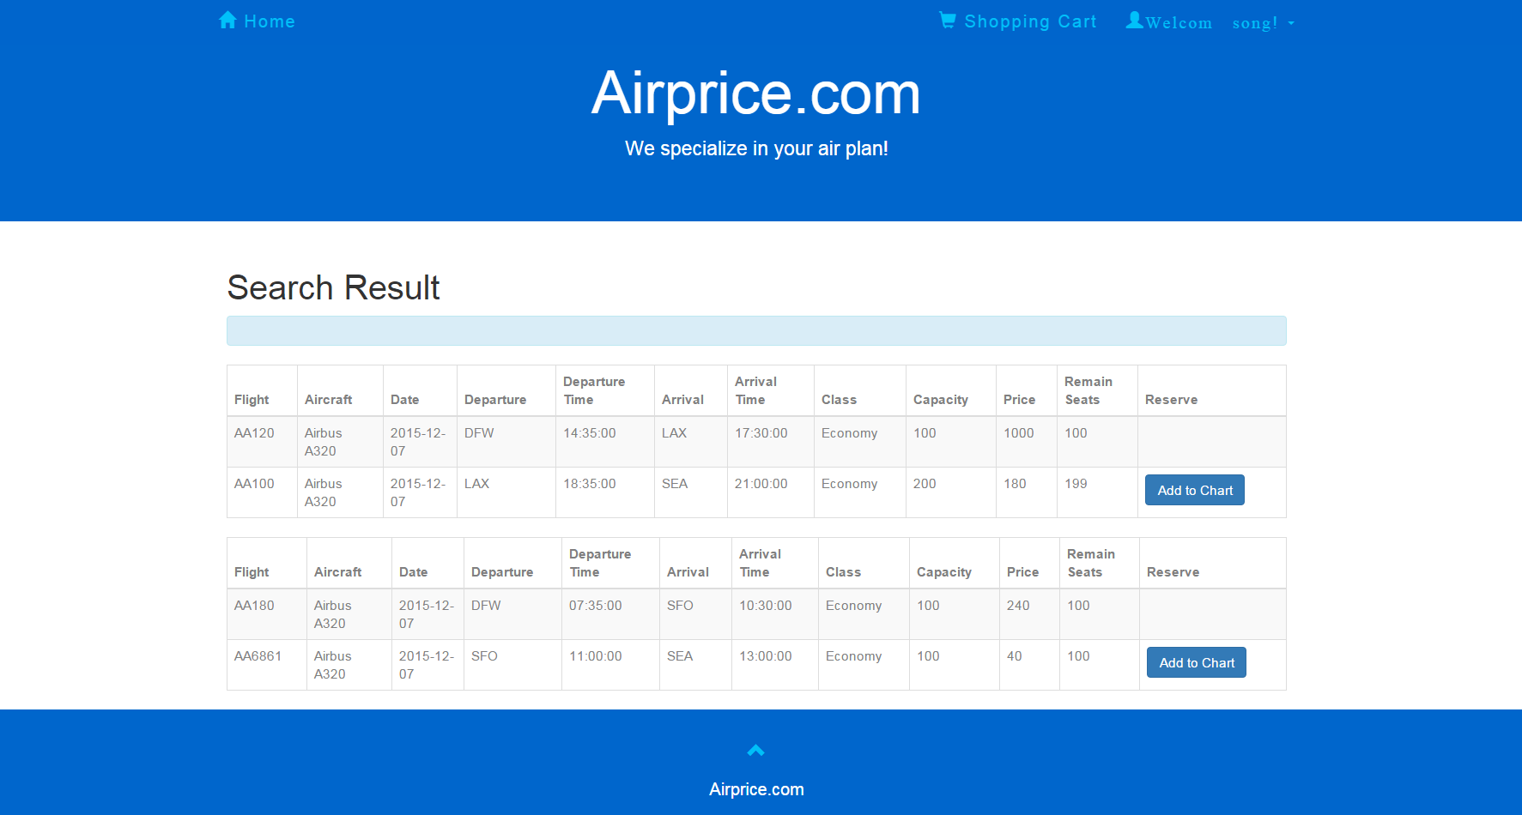

7. Admin page

